**Team name:** S23-22 ECE - Short throw automated theater backdrop

**Project Name & Sponsor:** Short throw automated theater backdrop

**SME and Customer - Name, email and phone number:**

**Customer Name:** Valerie Ransbottom

**Customer Email:** [valerieransbottom@mcps.org](mailto:valerieransbottom@mcps.org)

**Customer Phone Number:** 540.394.2180 ext. 4335

**SME Name:** Gustavo Araoz

**SME Email:** gearaoz@vt.edu

**SME Phone Number:** 540-231-7472

**Team Picture**

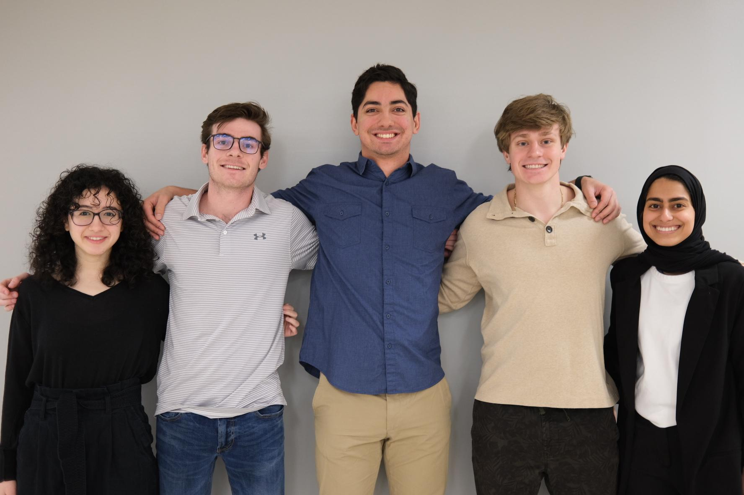

*From Left to Right: Mariam Singer, Jackson Pittman , Greg Brinson , Frank Shay and Fatima Alkaabi.*

**Team Status:**

***Team Members:***

1. **Fatima Alkaabi - *Communication Lead -*  (Interface Lead)**
   1. Email: [Fatima19@vt.edu](mailto:Fatima19@vt.edu)
   2. Phone Number: 540-998-8577
   3. Current Health & Welfare: Well
   4. Challenges that impact team participation: None
   5. Special skills/contributions/limitations: Responsible for the Interface component of the project.
   6. Permanent Location: Abu Dhabi,UAE
   7. Current Location: Blacksburg,VA
   8. Inventory & list all available means of communications to identify primary and alternate(s): Currently has the tablet and Raspberry Pi.

* Ways of reaching to Fatima:
  + 1. Personal Email: [alkaabifatima330@gmail.com](mailto:alkaabifatima330@gmail.com)
    2. LinkedIn: <https://www.linkedin.com/in/fatimainventor/>
* Date/time of last contact: 01/26/2023

1. **Frank Charles Shay V - *Team Representative* - ( Mounting and Electrical Lead)** 
   1. Email: [shayfcv@vt.edu](mailto:shayfcv@vt.edu)
   2. Phone Number: 757-807-4997
   3. Current Health & Welfare: Well
   4. Challenges that impact team participation: None
   5. Special skills/contributions/limitations: Projector Research, Mount Research, Electrical Wires, and 3D Software design.
   6. Permanent Location: Charlotte, NC
   7. Current Location: Blacksburg, VA
   8. Inventory & list all available means of communications to identify primary and alternate(s):

* Ways of reaching to Frank Shay
* Personal Email: [shayfcv@gmail.com](mailto:shayfcv@gmail.com)
* LinkedIn: [https://www.linkedin.com/in/frank-shay-1055b3192](https://www.linkedin.com/in/frank-shay-1055b3192/)
* Date/time of last contact: 01/26/2023

1. **Greg Sebastian Brinson - *Research Lead* (Backdrop Lead)** 
   1. Email: [greg808@vt.edu](mailto:greg808@vt.edu)
   2. Phone Number: 254-681-6781
   3. Current Health & Welfare: Great
   4. Challenges that impact team participation: None
   5. Special skills/contributions/limitations: Projector Screen Research and Projector Case Design
   6. Permanent Location: New Bern, NC
   7. Current Location: Blacksburg, VA
   8. Inventory & list all available means of communications to identify primary and alternate(s):

* Ways of reaching to Frank Shay
* Personal Email: [gregsbrinson@gmail.com](mailto:gregsbrinson@gmail.com)
* LinkedIn: <https://www.linkedin.com/in/greg-brinson-808/>
* Date/time of last contact: 1/22/2023

1. **Jackson Pittman - *Design Lead* (Lens Lead)** 
   1. Email: [jackson01@vt.edu](mailto:jackson01@vt.edu)
   2. Phone Number: 410-456-3701
   3. Current Health & Welfare: Great
   4. Challenges that impact team participation: None
   5. Special skills/contributions/limitations: Optics(both freespace and fiber coupled or guided wave)/lens assembly/na
   6. Permanent Location: Ellicott City, MD
   7. Current Location: Blacksburg, VA
   8. Inventory & list all available means of communications to identify primary and alternate(s): parts being ordered currently
      1. Linkedin: <https://www.linkedin.com/in/jackson-pittman-862036198/>

* Date/time of last contact: 1/23/2023

1. **Mariam Singer - *Implementation Lead* (Motor )**
   1. Email: [MariamSinger@vt.edu](mailto:MariamSinger@vt.edu)
   2. Phone Number: 202-813-5003
   3. Current Health & Welfare: Good
   4. Challenges that impact team participation: None
   5. Special skills/contributions/limitations: Motor control and screen assembly
   6. Permanent Location: Fairfax, VA
   7. Current Location: Blacksburg, VA
   8. Inventory & list all available means of communications to identify primary and alternate(s): Currently have the Raspberry Pi; Means of communication:
      1. Email: [MariamSinger@vt.edu](mailto:MariamSinger@vt.edu)

* Date/time of last contact: 1/23/2023

**Mentor**: Kelley Dunning-Andrews ([Kelley.Dunning-Andrews@ge.com](mailto:Kelley.Dunning-Andrews@ge.com))

**Customer:** Valerie Ransbotton ([valerieransbottom@mcps.com](mailto:valerieransbottom@mcps.com))

**SME:** Gustavo Araoz, ICAT ([gearaoz@vt.edu](mailto:gearaoz@vt.edu))

**SCHEDULED COMMUNICATIONS**

1. **Team meetings:** [**Team Calendar**](https://calendar.google.com/calendar/u/0?cid=Y19lOWMyYjU1YmZmNGUyMGI1MDcyMDI1OGQ1NjQ1MjZhZWU3N2MxYmY5N2UxOTcwMTNmMjU4MTRmY2E1ZjZkM2Y5QGdyb3VwLmNhbGVuZGFyLmdvb2dsZS5jb20)

* Team Meetings every Monday and Wednesday after Official Meetings. 12:30 pm - 2:00 pm.

1. **SME meetings:** [**SME Meeting Calendar**](https://calendar.google.com/calendar/u/0?cid=Y183ZWJhYzFhM2MyNDg0NGU4MWE3NjY2NWU0OGYxYTk4ZDkzNDcyNzE2OGZhMzU5MzdhYzk2Y2ExNmQxMmM5ZTAyQGdyb3VwLmNhbGVuZGFyLmdvb2dsZS5jb20)

* SME Meeting every other Wednesday on Zoom (unless specified) 12:30 pm - 1:30 pm.

1. **Customer meetings:** [**Customer Meeting Calendar**](https://calendar.google.com/calendar/u/0?cid=Y18xMWQzNWJhNTg3ZTM3MGMwMjZlZDIwZDlhNjBiODg0YzUzYTNiOGFiYWMxNTU5NDM4YTQ4ZWMwODM2MjgwZWUzQGdyb3VwLmNhbGVuZGFyLmdvb2dsZS5jb20)

* Customer meeting every other Wednesday on Zoom (unless specified) 12:30pm - 1:30 pm.

1. **Mentor meetings:** [**Mentor Meeting Calendar**](https://calendar.google.com/calendar/u/0?cid=Y180M2I3OTk3ZDAxMDY3ZThkYzY0YzI4NmU1NzE0OTA5NzY5OGM4YjE4NTNkYzUwOThkZGYyOWQzZmFkMmYzNDU4QGdyb3VwLmNhbGVuZGFyLmdvb2dsZS5jb20)

* Team Meetings with Mentor every Monday on Zoom (unless specified) 12:30 pm - 1:30 pm.